Scene 1

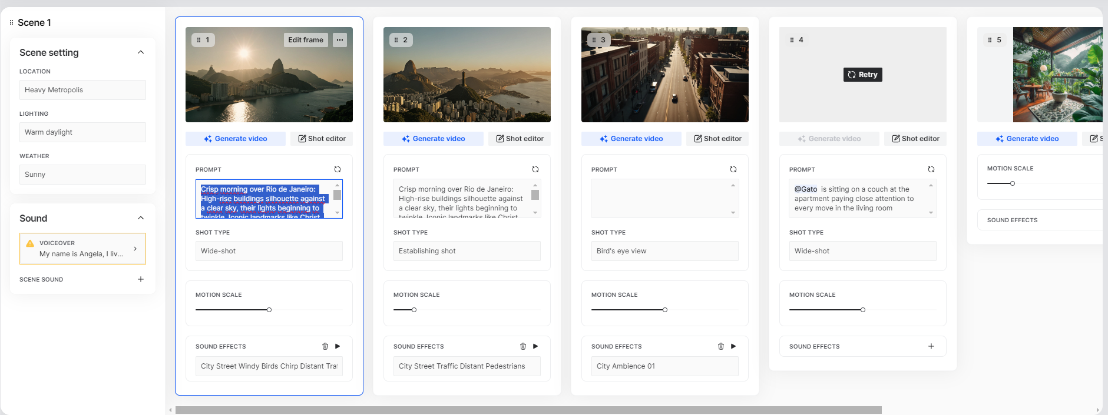

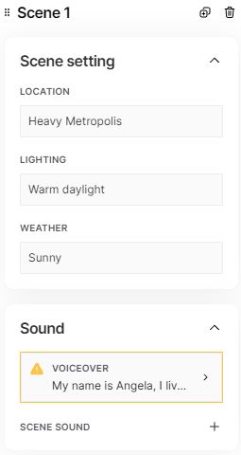

Voiceover 1

My name is Angela, I live in Rio with my cat, and he loves to chase bugs, I always thought insects were just, well, bugs. Thats when It clicked me, that something amidst my plants, caught my attention.

Shot 1

Wide-shot

Crisp morning over Rio de Janeiro: High-rise buildings silhouette against a clear sky, their lights beginning to twinkle. Iconic landmarks like Christ redeemer stand out, while moving trains and bustling streets below hint at the city's ever-present energy. The skyline is a harmonious blend of modernity and tradition, reflecting Copacabana's unique character.

Shot 2

Establishing shot

Crisp morning over Rio de Janeiro: High-rise buildings silhouette against a clear sky, their lights beginning to twinkle. Iconic landmarks like Christ redeemer stand out, while moving trains and bustling streets below hint at the city's ever-present energy.

Shot 3

Bird's eye view

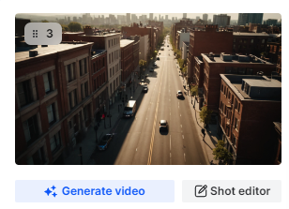

Shot 4

Medium shot

@Gato is sitting on a couch at the apartment paying close attention to every move in the living room

Shot 5

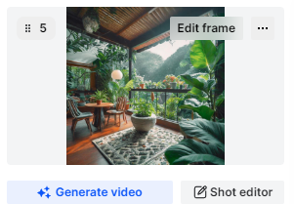

Shot 6
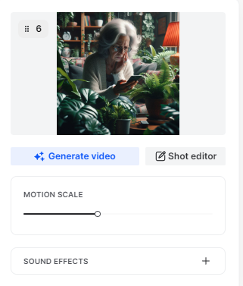

Scene 2

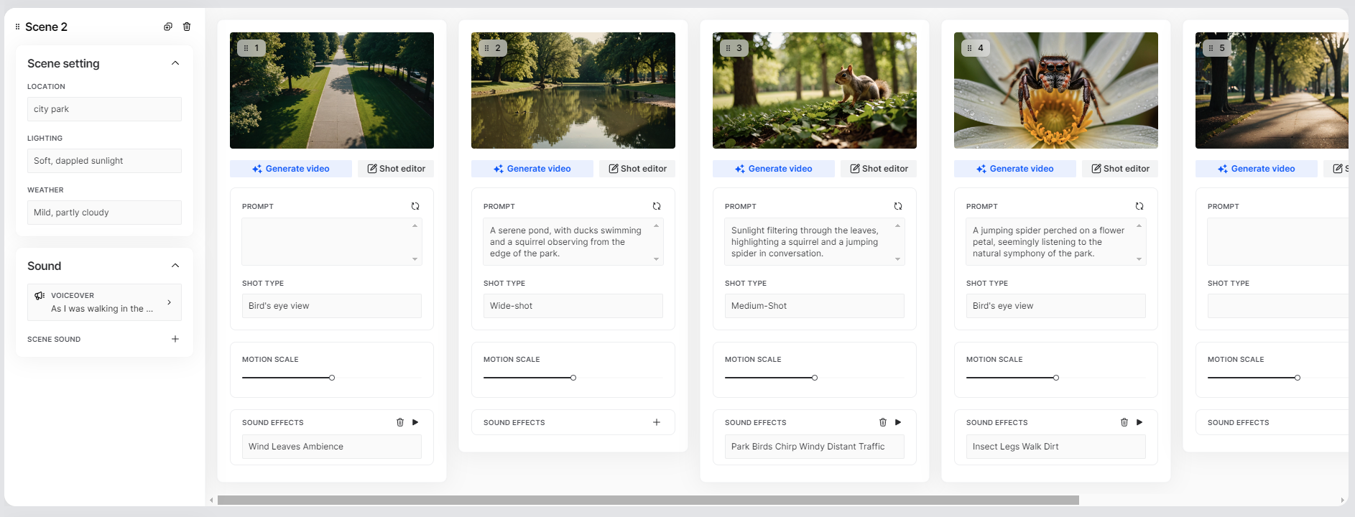

Voiceover

As I was walking in the park and paying close attention to what the elders at the park were saying, I started noticing things, little signs that they might be onto something else.

Shot 1

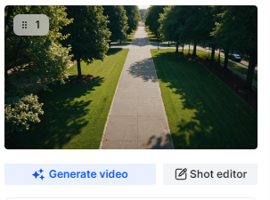

Bird's eye view

Shot 2

Wide-shot

A serene pond, with ducks swimming and a squirrel observing from the edge of the park.
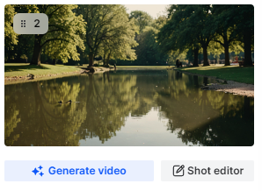

Shot 3

Medium shot

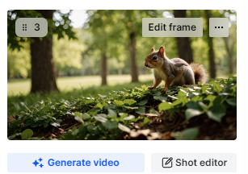

Sunlight filtering through the leaves, highlighting a squirrel and a jumping spider in conversation.

Shot 4

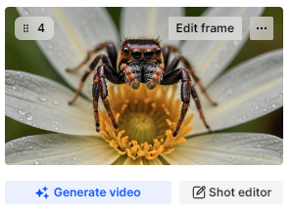

A jumping spider perched on a flower petal, seemingly listening to the natural symphony of the park.

Shot 5

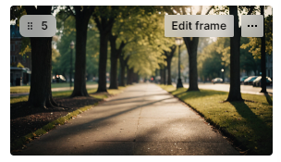

Shot 6

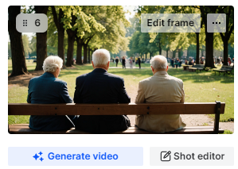

A group of elders sitting on a bench in the park

Behind shot

Scene 3

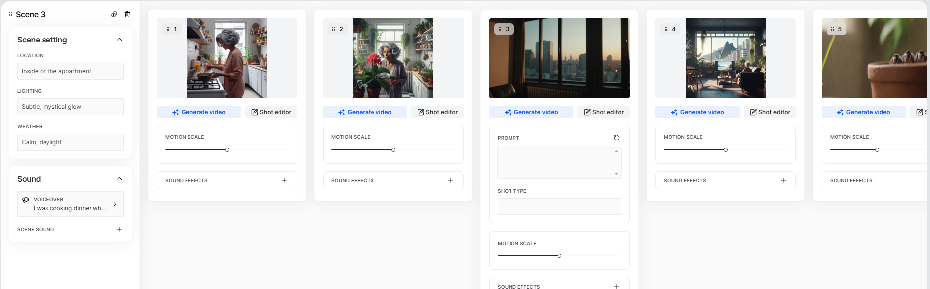

I was cooking dinner when I felt a weird feeling that was not new, but still very odd, like there were some kind of mumbling amidst my plants, how odd! I just had to take a closer look

